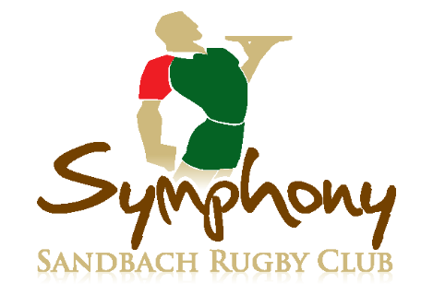

Express Menu

All £4 each

Burgers and grills

•Bacon and cheese burger
•Prime steak burger with pepper sauce
•Symphony burger with cheese, black pudding and
red & green pepper salsa
Served with chips house slaw and salsa

Salads
•Chicken Caesar salad
•Cajun salmon salad
•Prawn salad
•Symphony salad with chicken, prawns, smoked salmon, peaches and strawberries

Large bites
•Chicken Dijon
•Scampi with homemade tartare sauce
•Cajun chicken wrap
•Smoked salmon and soft cheese wrap
•Goat’s cheese, mushroom and cranberry wrap
Served with fries & garnish where appropriate.

Burgers and grills
•Bacon and cheese burger
•Prime steak burger with pepper sauce
•Symphony burger with cheese, black pudding and
red & green pepper salsa
•Pork steak •Gammon steak
•Chicken breast
•Hake fillet •Tuna steak
Served with chips house slaw and salsa
Burgers and grills
•Bacon and cheese burger
•Prime steak burger with pepper sauce
•Symphony burger with cheese, black pudding and
red & green pepper salsa
•Pork steak •Gammon steak
•Chicken breast
•Hake fillet •Tuna steak
Served with chips house slaw and salsa
Full menu

Starters | £
Homemade soup of the day  Prawn cocktail  Black pudding with mustard mayonnaise  Smoked salmon with lemon and cracked black pepper  Creamy garlic mushrooms on toast  Warm goat’s cheese & cranberry salad | 1.50  3.50  2.50  3.50  2.50  2.50
Main courses
Fillet steak 8 oz  Sirloin steak 8oz  Rump steak 8oz  Steak special – fillet and sirloin 1lb  Gammon steak  Mixed meat platter – 8oz rump and 8oz gammon  Butterflied chicken breast  Salmon steak  Fresh filleted whole sea bass  Fillet and bacon kebab  All served with fries, dressed leaves and coleslaw. | 11.00  8.00  6.50  16.00  5.00  10.00  5.00  6.00  9.00  10.00
Side orders
Sauces – pepper, blue cheese, or garlic  Garlic bread  Garlic bread with cheese  Tortilla sticks and dips  Tomatoes, onion rings and mushrooms | 1.00  2.00  2.00  2.00  2.00

